Cin Cin Holiday Cookies
Cin Cin has a variety of freshly made holiday cookies. We package our orders in festive holiday boxes for pickup, or hard tins for shipping. Let Cin Cin ship cookies to your family, friends, or special clients. Homemade cookies are a great way to let people know you are thinking of them this holiday season! Or, treat yourself this holiday season! Orders must be placed seventy-two hours prior to pick-up date and prior to December 18.

GRAND MARNIER ORANGE COOKIES
MEXICAN WEDDING CHOCOLATE
DIPPED SHORTBREAD

ESPRESSO CHOCOLATE COOKIE
MERINGUE KISSES*
TOFFEE SQUARES* CUT OUT KIT*

$7.50/DOZEN

$9.00/DOZEN

$7.50/DOZEN

$7.00/DOZEN

$4.00/DOZEN

$7.00/DOZEN

$10.00/DOZEN
MACAROONS* W/ITALIAN CREAM
MACAROONS* W/ITALIAN CREAM & RASPBERRY

CANDY CANE CRISP BOURBON BALLS RUM BALLS BRANDY BALLS

$7.50/DOZEN

$7.50/DOZEN

$7.50/DOZEN

$7.50/DOZEN

$7.50/DOZEN

$7.50/DOZEN

GOURMET DOG BISCUITS
Don't forget your furry family members! We now offer gourmet and preservative-free dog biscuits made from real protein and whole grains.
BACON
CHEDDAR
PEANUT BUTTER
$7 PER DOZEN

*Gluten Free
*The Cut Out Kit Includes a variety of shapes of cut cookies and 3 different colored icing.
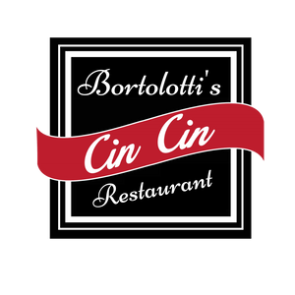
Receive $2 off total for every 4 dozen ordered. Receive $3 off total for every 6 dozen ordered

Order form

Name | Shipped By or Pickup Date:
Address(es) (if shipping)
Phone/Email

Cookie | QTY | Price/Doz | Shipping (S) or Pickup (P) | Total
 |  |  | Subtotal
 |  |  | Discount
 |  |  | Total
*Shipping per address= 1-2 Dozen $14 (w/tin), 3-5 dozen $18 (w/tin) |  |  | Shipping
 |  |  | Taxes (5.5% of Total)
Return completed form to aubreydalbec@gmail.com |  |  | Grand Total

Checks can be made payable to Jessica’s Cucina PO Box 914, Eagle River, WI 54521. Credit card payments will incur 3.5% processing fee. Contact us: aubreydalbec@gmail.com, 715-891-0775

